**AWS CCP PRACTICE QUESTIONS**

**(Billing and Pricing)**

**BILLING AND PRICING**

**Question 1:**

A startup wants to set up its IT infrastructure on AWS Cloud. The CTO would like to get an estimate of the monthly AWS bill based on the AWS services that the startup wants to use. As a Cloud Practitioner, which AWS service would you suggest for this use-case?

1. AWS Budgets
2. AWS Total Cost of Ownership (TCO) Calculator
3. AWS Cost Explorer
4. AWS Simple Monthly Calculator (**Correct**)

#### **Explanation**

Correct option:

**AWS Simple Monthly Calculator**

The Simple Monthly Calculator provides an estimate of usage charges for AWS services based on certain information you provide. It helps customers and prospects estimate their monthly AWS bill more efficiently.

This calculator provides a visual interface to enter details about the AWS services that you plan to use and then it outputs a detailed estimate of the monthly AWS bill. Please see the illustration for more details:

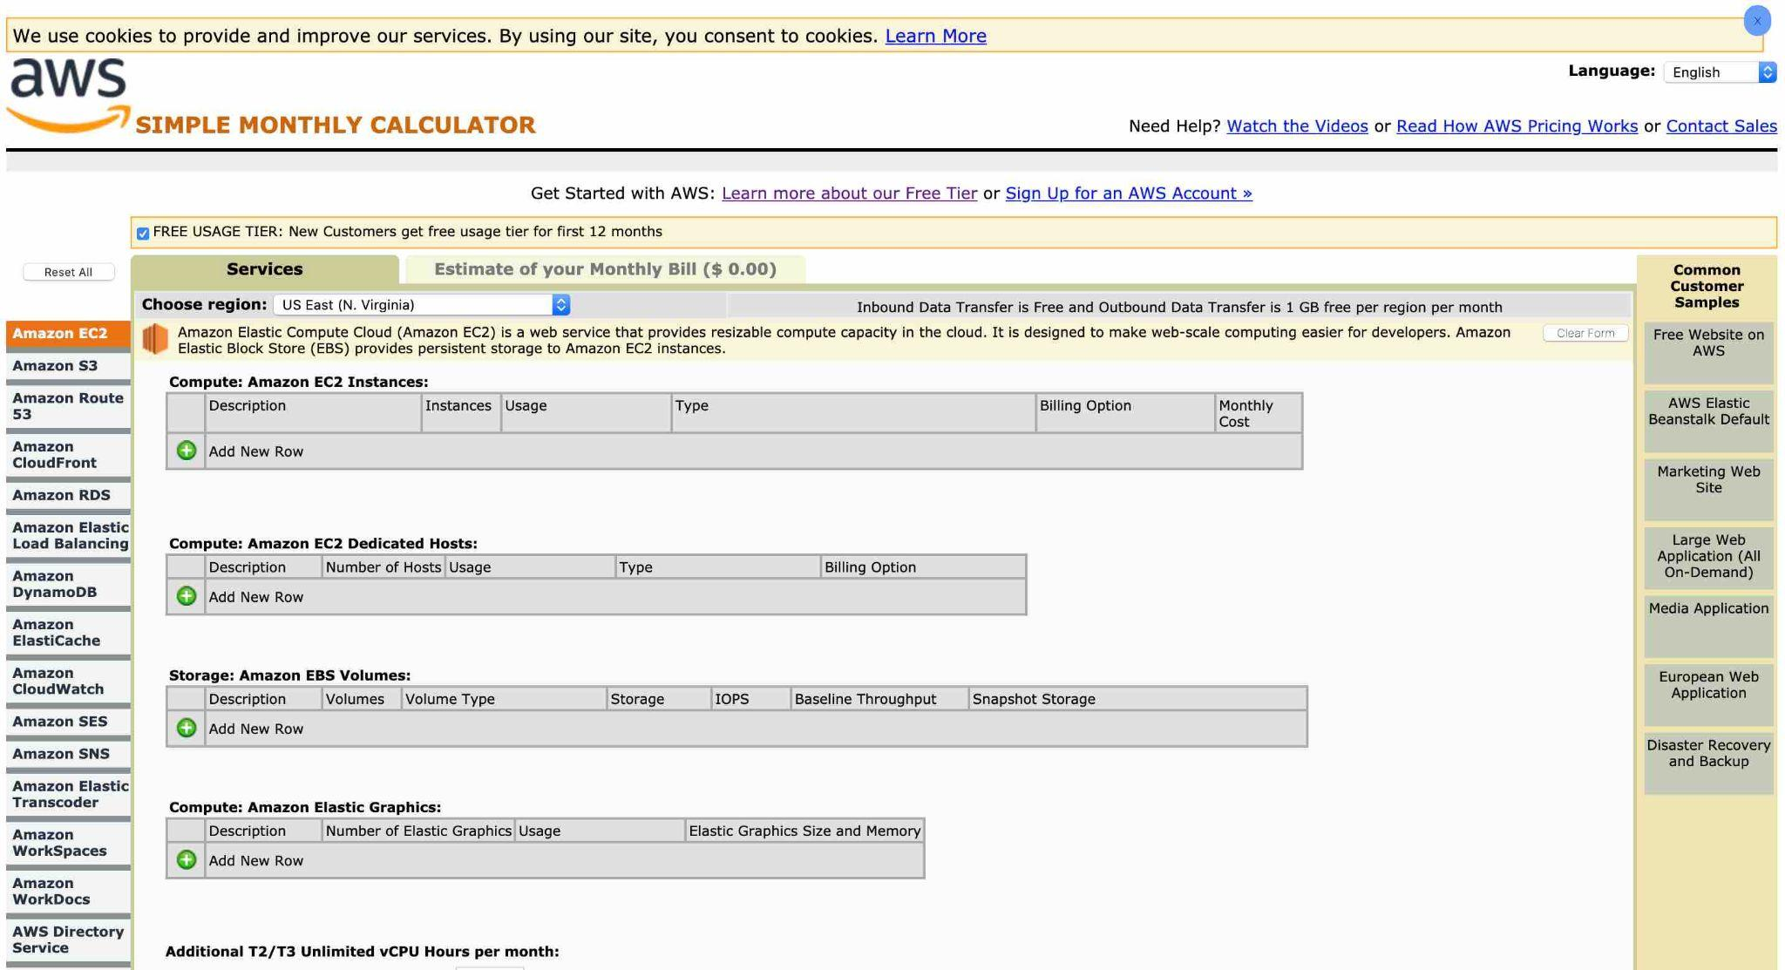

Incorrect options:

**AWS Total Cost of Ownership (TCO) Calculator**

TCO calculator helps to compare the cost of your applications in an on-premises or traditional hosting environment to AWS. AWS helps reduce Total Cost of Ownership (TCO) by reducing the need to invest in large capital expenditures and providing a pay-as-you-go model that empowers to invest in the capacity you need and use it only when the business requires it. Once you describe your on-premises or hosting environment configuration, it produces a detailed cost comparison with AWS. TCO Calculator cannot provide the estimate of the monthly AWS bill based on the list of AWS services.

**AWS Cost Explorer** - AWS Cost Explorer has an easy-to-use interface that lets you visualize, understand, and manage your AWS costs and usage over time. AWS Cost Explorer includes a default report that helps you visualize the costs and usage associated with your top five cost-accruing AWS services, and gives you a detailed breakdown of all services in the table view. The reports let you adjust the time range to view historical data going back up to twelve months to gain an understanding of your cost trends. AWS Cost Explorer cannot provide the estimate of the monthly AWS bill based on the list of AWS services.

**AWS Budgets** - AWS Budgets gives the ability to set custom budgets that alert you when your costs or usage exceed (or are forecasted to exceed) your budgeted amount. You can also use AWS Budgets to set reservation utilization or coverage targets and receive alerts when your utilization drops below the threshold you define. Budgets can be created at the monthly, quarterly, or yearly level, and you can customize the start and end dates. You can further refine your budget to track costs associated with multiple dimensions, such as AWS service, linked account, tag, and others. AWS Budgets cannot provide the estimate of the monthly AWS bill based on the list of AWS services.

Reference:

<https://calculator.s3.amazonaws.com/index.html>

Question 2:

The DevOps team at an IT company is moving 500 GB of data from an EC2 instance to an S3 bucket in the same region. Which of the following scenario captures the correct charges for this data transfer?

1. The company would be charged for both the outbound data transfer from EC2 instance as well as the inbound data transfer into the S3 bucket.
2. The company would not be charged for the data transfer (**Correct**)
3. The company would only charge for the inbound data transfer into the S3 bucket
4. The company would only be charged for the outbound data transfer from EC2 instance.

#### **Explanation**

Correct option:

**The company would not be charged for this data transfer**

There are three fundamental drivers of cost with AWS: compute, storage, and outbound data transfer. In most cases, there is no charge for inbound data transfer or data transfer between other AWS services within the same region. Outbound data transfer is aggregated across services and then charged at the outbound data transfer rate.

Per AWS pricing, data transfer between S3 and EC2 instances within the same region is not charged, so there would be no data transfer charge for moving 500 GB of data from an EC2 instance to an S3 bucket in the same region.

Incorrect options:

**The company would only be charged for the outbound data transfer from EC2 instance**

**The company would only be charged for the inbound data transfer into the S3 bucket**

**The company would be charged for both the outbound data transfer from EC2 instance as well as the inbound data transfer into the S3 bucket**

These three options contradict the details provided earlier in the explanation, so these options are incorrect.

Reference:

<https://aws.amazon.com/s3/pricing/>

<https://d0.awsstatic.com/whitepapers/aws_pricing_overview.pdf>

Question 3:

Which of the following AWS Support plans provide access to guidance, configuration, and troubleshooting of AWS interoperability with third-party software? (Select two)

1. Basic
2. Developer
3. Corporate (**Correct**)
4. Business
5. Enterprise (**Correct**)

#### **Explanation**

Correct options:

**Enterprise** - AWS Enterprise Support provides customers with concierge-like service where the main focus is helping the customer achieve their outcomes and find success in the cloud. With Enterprise Support, you get 24x7 technical support from high-quality engineers, tools and technology to automatically manage the health of your environment, consultative architectural guidance delivered in the context of your applications and use-cases, and a designated Technical Account Manager (TAM) to coordinate access to proactive/preventative programs and AWS subject matter experts. You get access to guidance, configuration, and troubleshooting of AWS interoperability with many common operating systems, platforms, and application stack components.

**Business** - AWS recommends Business Support if you have production workloads on AWS and want 24x7 phone, email and chat access to technical support and architectural guidance in the context of your specific use-cases. You get full access to AWS Trusted Advisor Best Practice Checks. You get access to guidance, configuration, and troubleshooting of AWS interoperability with many common operating systems, platforms, and application stack components.

Exam Alert:

Please review the differences between the Developer, Business, and Enterprise support plans as you can expect at least a couple of questions on the exam:

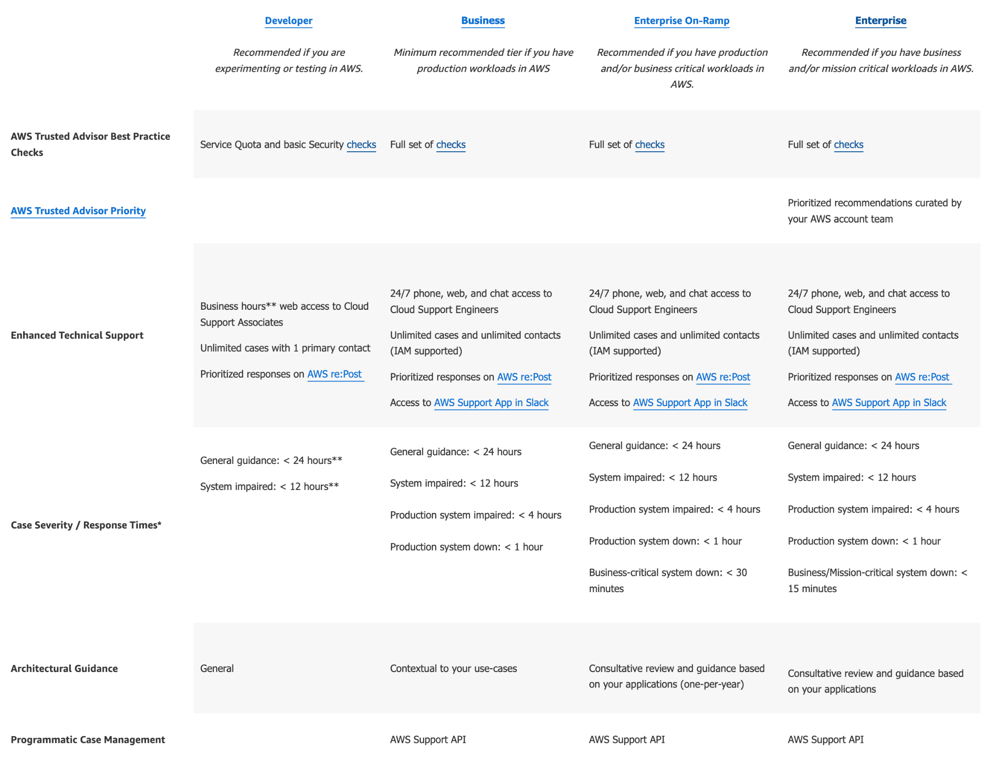

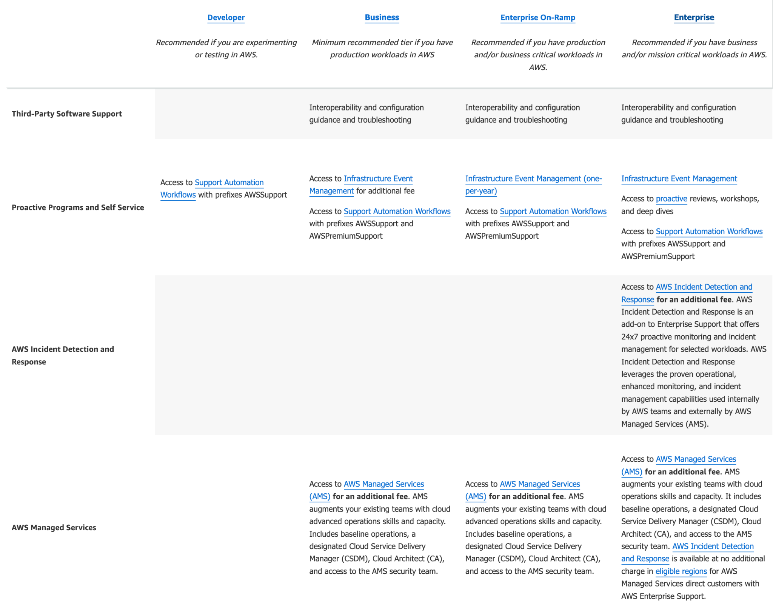

Incorrect options:

**Basic** - The basic plan only provides access to the following:

Customer Service & Communities - 24x7 access to customer service, documentation, whitepapers, and support forums. AWS Trusted Advisor - Access to the 7 core Trusted Advisor checks and guidance to provision your resources following best practices to increase performance and improve security. AWS Personal Health Dashboard - A personalized view of the health of AWS services, and alerts when your resources are impacted.

**Developer** - AWS recommends Developer Support plan if you are testing or doing early development on AWS and want the ability to get email-based technical support during business hours. This plan also supports general guidance on how services can be used for various use cases, workloads, or applications. You do not get access to Infrastructure Event Management with this plan.

Both these plans do not support access to guidance, configuration, and troubleshooting of AWS interoperability with third-party software.

**Corporate** - This is a made-up option and has been added as a distractor.

**Reference:**

[**https://aws.amazon.com/premiumsupport/plans/**](https://aws.amazon.com/premiumsupport/plans/)

**Question 4:**

Which of the following AWS Support plans provides access to Infrastructure Event Management for an additional fee?

1. Business (**Correct**)
2. Enterprise
3. Basic
4. Developer

#### **Explanation**

Correct option:

**Business** - AWS recommends Business Support if you have production workloads on AWS and want 24x7 phone, email and chat access to technical support and architectural guidance in the context of your specific use-cases. You get full access to AWS Trusted Advisor Best Practice Checks. Also, you get access to Infrastructure Event Management for an additional fee.

Incorrect options:

**Developer** - AWS recommends Developer Support if you are testing or doing early development on AWS and want the ability to get email-based technical support during business hours as well as general architectural guidance as you build and test. You do not get access to Infrastructure Event Management with this plan.

**Basic** - The basic plan only provides access to the following:

Customer Service & Communities - 24x7 access to customer service, documentation, whitepapers, and support forums. AWS Trusted Advisor - Access to the 7 core Trusted Advisor checks and guidance to provision your resources following best practices to increase performance and improve security. AWS Personal Health Dashboard - A personalized view of the health of AWS services, and alerts when your resources are impacted. You do not get access to Infrastructure Event Management with this plan.

**Enterprise** - AWS Enterprise Support provides customers with concierge-like service where the main focus is helping the customer achieve their outcomes and find success in the cloud. With Enterprise Support, you get 24x7 technical support from high-quality engineers, tools and technology to automatically manage the health of your environment, consultative architectural guidance delivered in the context of your applications and use-cases, and a designated Technical Account Manager (TAM) to coordinate access to proactive/preventative programs and AWS subject matter experts. Access to Infrastructure Event Management is included in the plan.

Reference:

<https://aws.amazon.com/premiumsupport/plans/>

Question 5:

Which of the following AWS services support reservations to optimize costs? (Select three)

1. AWS Lambda
2. AWS DynamoDB (**Correct**)
3. AWS RDS (**Correct**)
4. AWS EC2 Instances (**Correct**)
5. DocumentDB
6. S3

#### **Explanation**

Correct options:

**EC2 Instances**

**DynamoDB**

**RDS**

The following AWS services support reservations to optimize costs:

Amazon EC2 Reserved Instances: You can use Amazon EC2 Reserved Instances to reserve capacity and receive a discount on your instance usage compared to running On-Demand instances.

Amazon DynamoDB Reserved Capacity: If you can predict your need for Amazon DynamoDB read-and-write throughput, Reserved Capacity offers significant savings over the normal price of DynamoDB provisioned throughput capacity.

Amazon ElastiCache Reserved Nodes: Amazon ElastiCache Reserved Nodes give you the option to make a low, one-time payment for each cache node you want to reserve and, in turn, receive a significant discount on the hourly charge for that node.

Amazon RDS RIs: Like Amazon EC2 RIs, Amazon RDS RIs can be purchased using No Upfront, Partial Upfront, or All Upfront terms. All Reserved Instance types are available for Aurora, MySQL, MariaDB, PostgreSQL, Oracle, and SQL Server database engines.

Amazon Redshift Reserved Nodes: If you intend to keep an Amazon Redshift cluster running continuously for a prolonged period, you should consider purchasing reserved-node offerings. These offerings provide significant savings over on-demand pricing, but they require you to reserve compute nodes and commit to paying for those nodes for either a 1- or 3-year duration.

Incorrect options:

**DocumentDB** - Amazon DocumentDB (with MongoDB compatibility) is a fast, scalable, highly available, and fully managed document database service that supports MongoDB workloads. As a document database, Amazon DocumentDB makes it easy to store, query, and index JSON data.

**Lambda** - AWS Lambda lets you run code without provisioning or managing servers. You pay only for the compute time you consume.

**S3** - Amazon Simple Storage Service (Amazon S3) is an object storage service that offers industry-leading scalability, data availability, security, and performance.

None of these AWS services support reservations to optimize costs.

Reference:

<https://d0.awsstatic.com/whitepapers/aws_pricing_overview.pdf>

Question 6:

Which of the following is the MOST cost-effective option to purchase an EC2 Reserved Instance?

1. Partial upfront payment option with standard 3-years term (**Correct**)
2. All upfront payment option with standard 1-year term
3. No upfront payment option with standard 3-years terms
4. No upfront payment option with standard 1-year term

#### **Explanation**

Correct option:

**Partial upfront payment option with standard 3-years term**

You can use Amazon EC2 Reserved Instances to reserve capacity and receive a discount on your instance usage compared to running On-Demand instances. The discounted usage price is reserved for the duration of your contract, allowing you to predict compute costs over the term of the Reserved Instance.

Please review this pricing comparison for EC2 Reserved Instances:

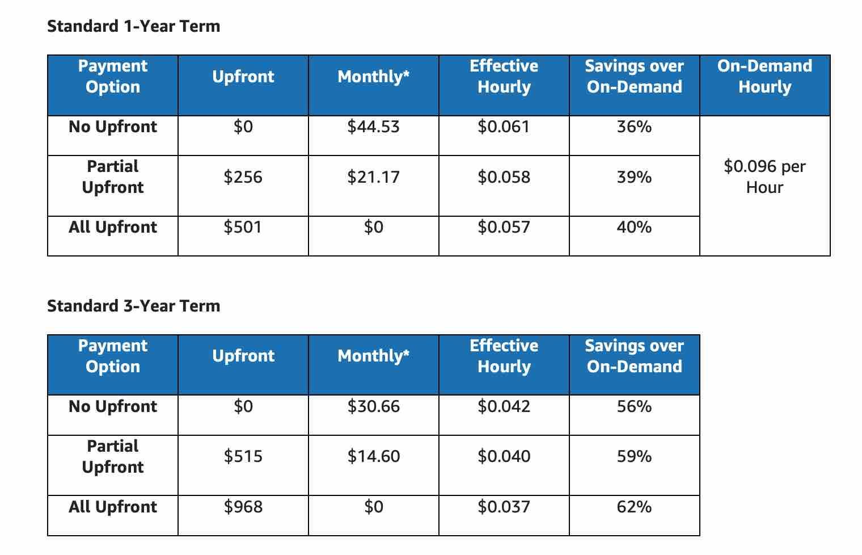

via - <https://d0.awsstatic.com/whitepapers/aws_pricing_overview.pdf>

So the percentage savings for each option is as follows:

"No upfront payment option with the standard 1-year term" - 36%

"All upfront payment option with the standard 1-year term" - 40%

"No upfront payment option with the standard 3-years term" - 56%

"Partial upfront payment option with the standard 3-years term" - 59%

**Exam Alert**:

For the exam, there is no need to memorize these savings numbers. All you need to remember is that a 3 years term would always be more cost-effective than a 1-year term. Then within a term, "all upfront" is better than "partial upfront" which in turn is better than "no upfront" from a cost savings perspective.

**No upfront payment option with standard 1-year term**

**No upfront payment option with standard 1-year term**

**No upfront payment option with standard 3-years term**

These three options contradict the details provided earlier in the explanation, so these options are incorrect.

Reference:

<https://d0.awsstatic.com/whitepapers/aws_pricing_overview.pdf>

Question 7:

Which AWS Support plan provides architectural guidance contextual to your specific use-cases?

* 1. Basic
* 2. Developer
* 3. Business (Correct)
* 4. Enterprise

#### 

#### 

#### **Explanation**

Correct option:

**Business** - AWS recommends Business Support if you have production workloads on AWS and want 24x7 phone, email and chat access to technical support and architectural guidance in the context of your specific use-cases. You get full access to AWS Trusted Advisor Best Practice Checks. You also get access to Infrastructure Event Management for an additional fee.

Incorrect options:

**Developer** - AWS recommends Developer Support if you are testing or doing early development on AWS and want the ability to get email-based technical support during business hours as well as general architectural guidance as you build and test. You do not get access to Infrastructure Event Management with this plan. This plan only supports general architectural guidance.

**Basic** - The basic plan only provides access to the following:

Customer Service & Communities - 24x7 access to customer service, documentation, whitepapers, and support forums. AWS Trusted Advisor - Access to the 7 core Trusted Advisor checks and guidance to provision your resources following best practices to increase performance and improve security. AWS Personal Health Dashboard - A personalized view of the health of AWS services, and alerts when your resources are impacted. This plan does not support any architectural guidance.

**Enterprise** - AWS Enterprise Support provides customers with concierge-like service where the main focus is helping the customer achieve their outcomes and find success in the cloud. With Enterprise Support, you get 24x7 technical support from high-quality engineers, tools and technology to automatically manage the health of your environment, consultative review and guidance based on your applications, and a designated Technical Account Manager (TAM) to coordinate access to proactive/preventative programs and AWS subject matter experts. This plan supports architectural guidance contextual to your application.

Reference:

<https://aws.amazon.com/premiumsupport/plans/>

Question 8:

A startup wants to provision an EC2 instance for the lowest possible cost for a long-term duration but needs to make sure that the instance would never be interrupted. As a Cloud Practitioner, which of the following options would you recommend?

1. On-Demand Instance
2. Reserved Instance (Correct)
3. Dedicated Host
4. Spot Instance

#### **Explanation**

Correct option:

**Reserved Instance** - Reserved Instances provide you with significant savings (up to 75%) on your Amazon EC2 costs compared to On-Demand Instance pricing. Reserved Instances are not physical instances, but rather a billing discount applied to the use of On-Demand Instances in your account. You can purchase a Reserved Instance for a one-year or three-year commitment, with the three-year commitment offering a bigger discount. Reserved instances cannot be interrupted. So this is the correct option.

EC2 Pricing Options Overview:

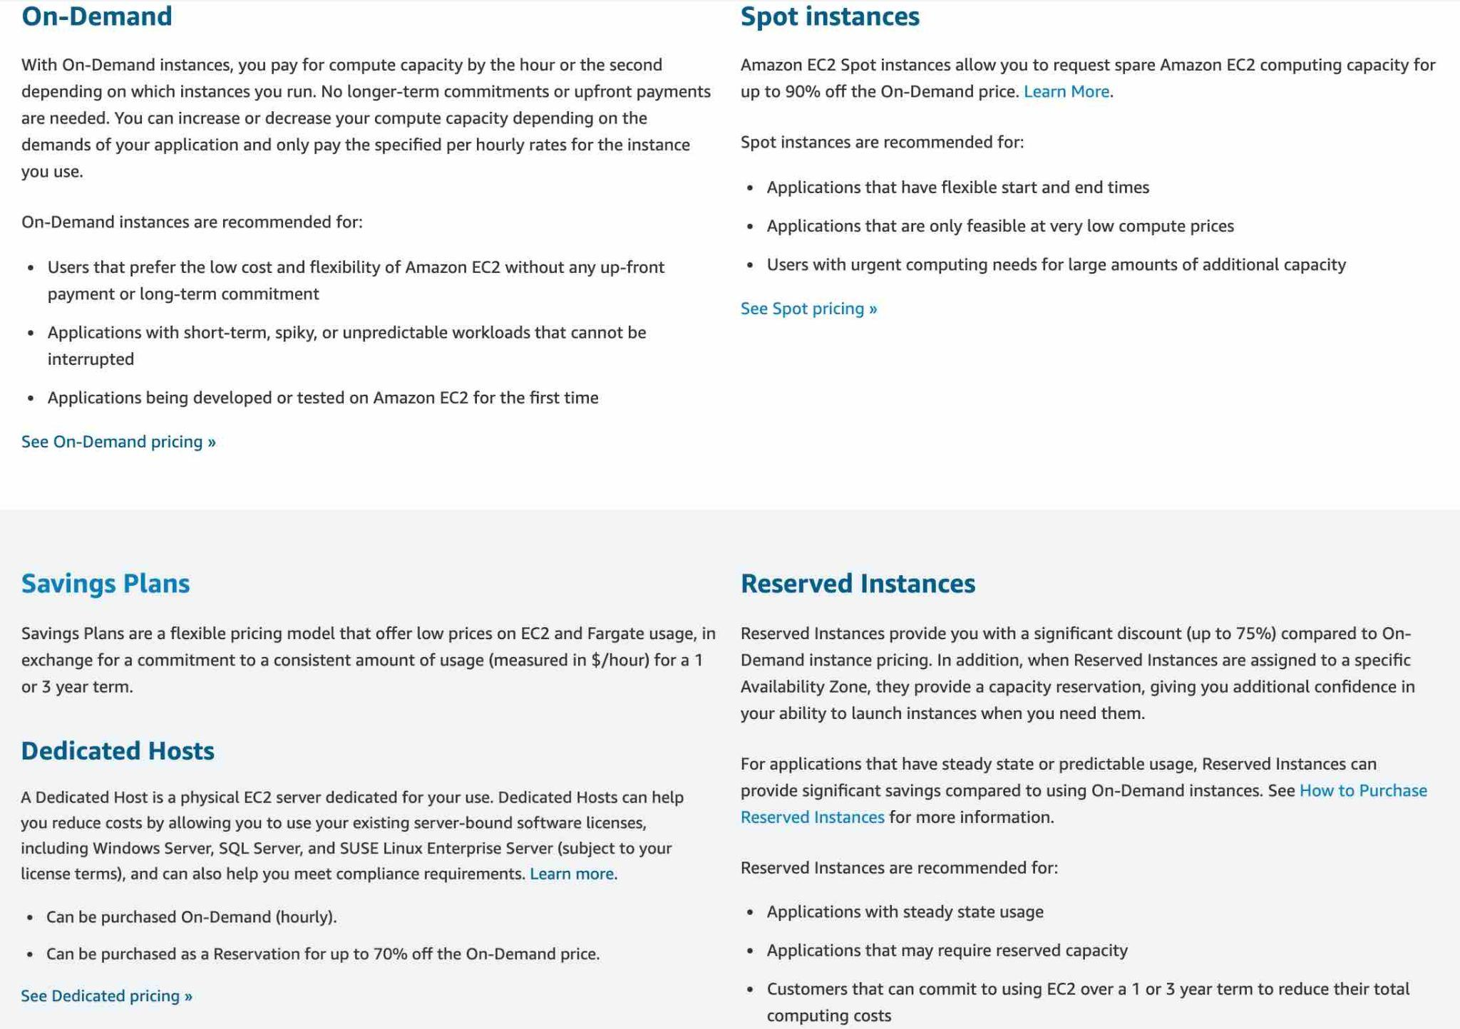

Incorrect options:

**On-Demand Instance** - An On-Demand Instance is an instance that you use on-demand. You have full control over its lifecycle — you decide when to launch, stop, hibernate, start, reboot, or terminate it. There is no long-term commitment required when you purchase On-Demand Instances. There is no upfront payment and you pay only for the seconds that your On-Demand Instances are running. The price per second for running an On-Demand Instance is fixed. On-demand instances cannot be interrupted. However, On-demand instances are not as cost-effective as Reserved instances, so this option is not correct.

**Spot Instance** - A Spot Instance is an unused EC2 instance that is available for less than the On-Demand price. Because Spot Instances enable you to request unused EC2 instances at steep discounts (up to 90%), you can lower your Amazon EC2 costs significantly. Spot Instances are well-suited for data analysis, batch jobs, background processing, and optional tasks. These can be terminated at short notice, so these are not suitable for critical workloads that need to run at a specific point in time. So this option is not correct for the given use-case.

**Dedicated Host** - Amazon EC2 Dedicated Hosts allow you to use your eligible software licenses from vendors such as Microsoft and Oracle on Amazon EC2 so that you get the flexibility and cost-effectiveness of using your licenses, but with the resiliency, simplicity, and elasticity of AWS. An Amazon EC2 Dedicated Host is a physical server fully dedicated for your use, so you can help address corporate compliance requirement. They're not cost-efficient compared to On-Demand instances. So this option is not correct.

Reference:

<https://aws.amazon.com/ec2/pricing/>

Question 9:

Which AWS service will help you receive alerts when the reservation utilization falls below the defined threshold?

1. AWS Budgets (Correct)
2. AWS Trusted Advisor
3. AWS CloudTrail
4. AWS Simple Monthly Calculator

#### 

#### **Explanation**

Correct option:

**AWS Budgets**

AWS Budgets gives you the ability to set custom budgets that alert you when your costs or usage exceed (or are forecasted to exceed) your budgeted amount.

You can also use AWS Budgets to set reservation utilization or coverage targets and receive alerts when your utilization drops below the threshold you define. Reservation alerts are supported for Amazon EC2, Amazon RDS, Amazon Redshift, Amazon ElastiCache, and Amazon Elasticsearch reservations.

Incorrect options:

**AWS Simple Monthly Calculator** - The Simple Monthly Calculator provides an estimate of usage charges for AWS services based on certain information you provide. It helps customers and prospects estimate their monthly AWS bill more efficiently. You cannot use this service to receive alerts when the reservation utilization falls below the defined threshold.

**AWS CloudTrail** - AWS CloudTrail is a service that enables governance, compliance, operational auditing, and risk auditing of your AWS account. With CloudTrail, you can log, continuously monitor, and retain account activity related to actions across your AWS infrastructure. CloudTrail provides event history of your AWS account activity, including actions taken through the AWS Management Console, AWS SDKs, command-line tools, and other AWS services. You cannot use this service to receive alerts when the reservation utilization falls below the defined threshold.

**AWS Trusted Advisor** - AWS Trusted Advisor is an online tool that provides real-time guidance to help provision your resources following AWS best practices. Whether establishing new workflows, developing applications, or as part of ongoing improvement, recommendations provided by Trusted Advisor regularly help keep your solutions provisioned optimally. AWS Trusted Advisor analyzes your AWS environment and provides best practice recommendations in five categories: Cost Optimization, Performance, Security, Fault Tolerance, Service Limits. You cannot use this service to receive alerts when the reservation utilization falls below the defined threshold.

References:

<https://aws.amazon.com/aws-cost-management/aws-budgets/>

<https://aws.amazon.com/premiumsupport/technology/trusted-advisor/best-practice-checklist/>

Question 10:

Which of the following AWS Support plans provides access to online training with self-paced labs?

1. Basic
2. Business
3. Enterprise (Correct)
4. Developer

#### **Explanation**

Correct option:

**Enterprise**

AWS offers three different support plans to cater to each of its customers - Developer, Business, and Enterprise Support plans. A basic support plan is included for all AWS customers.

AWS Enterprise Support provides customers with concierge-like service where the main focus is on helping the customer achieve their outcomes and find success in the cloud. With Enterprise Support, you get access to online training with self-paced labs, 24x7 technical support from high-quality engineers, tools and technology to automatically manage the health of your environment, consultative architectural guidance, a designated Technical Account Manager (TAM) to coordinate access to proactive/preventative programs and AWS subject matter experts.

AWS Enterprise Support Plan Offerings:

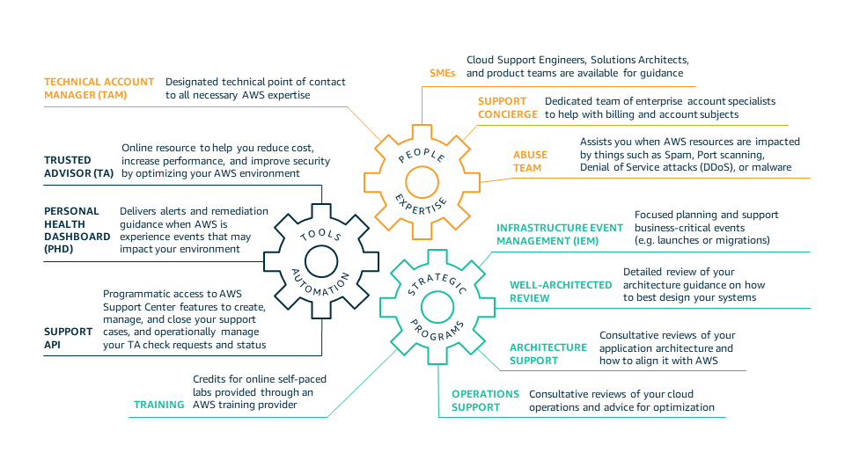

Incorrect options:

**Developer** - AWS recommends Developer Support if you are testing or doing early development on AWS and want the ability to get technical support during business hours as well as general architectural guidance as you build and test.

**Business** - AWS recommends Business Support if you have production workloads on AWS and want 24x7 access to technical support and architectural guidance in the context of your specific use-cases.

**Basic** - A basic support plan is included for all AWS customers.

None of these three support plans provide access to online training with self-paced labs.

References:

<https://aws.amazon.com/premiumsupport/plans/>

<https://aws.amazon.com/premiumsupport/plans/enterprise/>